📘 Three-Dimensional Jagged Array (Jagged 3D Array)

🧠 CORE POINT (Memorize This – MOST IMPORTANT)
👉 A jagged 3D array is accessed using three indexes, and each level can have different lengths.
This one line is the entire concept.

🔍 Explain the Core Point (Slow & Clear)

What does “different lengths at each level” mean?
• A jagged 3D array has three levels
• None of these levels are forced to be equal in size
Internally:
• Level 1 stores references to 2D arrays
• Level 2 stores references to 1D arrays
• Level 3 stores the actual values
📌 Every array at every level is created independently,
so their sizes can differ freely.
That is why it is called jagged at multiple levels.

🧩 How Indexing Works (Step-by-Step Thinking)

Example:
int[][][] arr = new int[3][][];

Step 1️⃣: First index
arr[1]
• This does not give values
• It gives one 2D array
So:
👉 First index → selects which 2D array

Step 2️⃣: Second index
arr[1][2]
• This does not give a value
• It gives one 1D array
So:
👉 Second index → selects which 1D array

Step 3️⃣: Third index
arr[1][2][4]
• Now we are inside the 1D array
• This gives the actual value
So:
👉 Third index → selects the value

🔑 Why it is called “Jagged 3D”
• Sizes are not fixed at any level
• 2D arrays can have different sizes
• 1D arrays inside them can also differ
📌 Uneven at level-2 + uneven at level-3
= Jagged 3D array

🧠 One-Line Memory Hook (Very Strong)
👉 First index selects a 2D array, second selects a 1D array, third selects the value — sizes can differ everywhere.
If you remember this line, you will never forget jagged 3D arrays.

❌ What NOT to Remember (Avoid Confusion)
❌ Cubes
❌ Fixed dimensions
❌ Equal sizes
These ideas belong to regular 3D arrays, not jagged ones.

✅ Final Perfect Definition (Exam + Interview Safe)
👉 A jagged 3D array in Java is a 3D array where each level stores references to independently created arrays, allowing different lengths at every level.

2️⃣ Syntax (Core Idea First)

🧠 CORE IDEA
👉 Create arrays level by level, deciding sizes step by step.

Step 1: Create the outermost array
int[][][] arr = new int[3][][];
• Creates 3 references to 2D arrays
• Deeper levels are not created yet

Step 2: Create second-level arrays
arr[0] = new int[2][];
arr[1] = new int[4][];
arr[2] = new int[3][];
• Each 2D array can have a different size

Step 3: Create third-level arrays
arr[0][0] = new int[4];
arr[0][1] = new int[2];

arr[1][0] = new int[3];
arr[1][1] = new int[1];
arr[1][2] = new int[5];
arr[1][3] = new int[2];

arr[2][0] = new int[3];
arr[2][1] = new int[4];
arr[2][2] = new int[3];
📌 Each inner array:
• Is created separately
• Can have any length

3️⃣ How Jagged 3D Array Is Stored in Memory

🧠 CORE IDEA
👉 A jagged 3D array is an array of arrays of arrays, all created independently in heap memory.

Stack Memory
• Stack stores only the reference variable arr
• arr points to heap
arr → heap

Heap Memory (Step-by-Step)

Level 1
• One array storing references to 2D arrays

Level 2
• Each reference points to a 2D array of references

Level 3
• Each reference points to a 1D array of actual values
✔️ Every array is a separate object
✔️ Sizes are not uniform

📌 Important Points to Lock in Memory
✔️ Jagged 3D array is still 3D
✔️ Every level stores references, not values (until last level)
✔️ No level is forced to be equal in size
✔️ Saves memory for uneven real-world data

4️⃣ Example Usage (Understand Indexing Clearly)
arr[1][2][4] = 85;
How Java reads this:
1️⃣ arr[1]
→ select the 2D array at index 1
2️⃣ arr[1][2]
→ select the 1D array at index 2
3️⃣ arr[1][2][4]
→ select index 4 and store value 85

In very simple words:
• First index → which 2D group
• Second index → which 1D group
• Third index → which value
• Stored value → 85

5️⃣ When Should We Use Jagged 3D Arrays?

🧠 CORE IDEA
👉 Use jagged 3D arrays when data is hierarchical and uneven at multiple levels.
Examples:
• Country → State → City
• College → Program → Student
• Company → Department → Team
• Application → Module → Feature

🧠 One-Line Gold Summary (Memorize This)
👉 A jagged 3D array is a 3D array where each level is created independently, allowing different sizes at every level.

Memory representation:
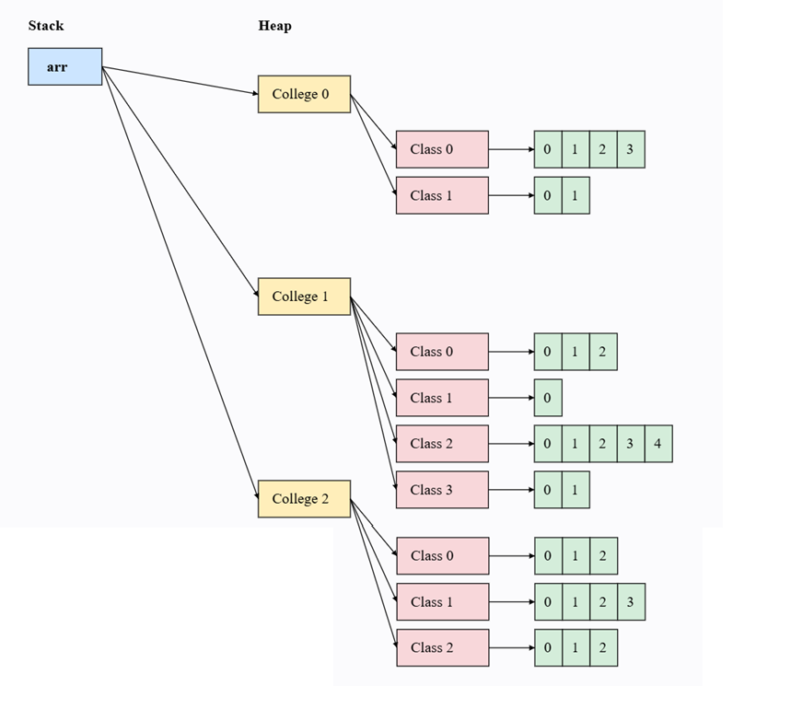

✅ Short Answer (Corrected & Precise)
👉 In C/C++, if an array size is 3 and you try to write at index 3, it will usually NOT throw an error.
Instead, it writes into memory outside the array.
This is called a Buffer Overrun.

🔍 Now Let’s Be Very Precise (Important)

Suppose this C code:
int arr[3];
arr[3] = 50;

What actually happens?
• arr has valid indexes: 0, 1, 2
• arr[3] is outside the array
❌ C does NOT check boundaries
❌ No automatic error is thrown

What happens to the value 50?
⚠️ Important correction to your sentence:
❌ “it will keep it at that size” → NOT correct
✅ Correct understanding:
- The value is written into some nearby memory location
- That memory does not belong to the array
- It may overwrite:
  - Another variable
  - Program data
  - Control information
📌 The array size does NOT increase.

🚨 Why This Is Dangerous (Buffer Overrun)
Because:
• Program continues running
• Memory corruption happens silently
• Program may crash later
• Or behave unpredictably
• Or create a security vulnerability
👉 This unsafe behavior is called Buffer Overrun (or Buffer Overflow).

⚠️ Very Important Interview Line (Memorize This)
👉 In C/C++, accessing beyond array bounds does not increase the array size; it causes memory corruption.

🔐 Contrast with Java (One-Line)
👉 Java stops execution immediately by throwing ArrayIndexOutOfBoundsException.

🧠 Final One-Line Gold Summary
👉 C/C++ allows writing outside array boundaries without error, leading to buffer overrun, whereas Java prevents this at runtime.

✅ Final Verdict on Your Statement
Your statement | Status
No error thrown | ✅ Correct
Value is stored | ⚠️ Partially correct
Stored inside array | ❌ Incorrect
Buffer overrun occurs | ✅ Correct

1️⃣ Arrays Are Objects (Very Important)

Core Concept
👉 Java arrays are objects, not raw memory blocks.
What this means:
• When an array is created, JVM stores:
- Space for values
- Array length information
Example:
int[] arr = new int[3];
Internally, JVM knows:
• This array can store exactly 3 values
• Valid index range is 0 to 2
📌 Length is stored inside the array object.

2️⃣ Runtime Boundary Checking (Main Security Mechanism)

🧠 CORE IDEA
👉 Every array access is checked by the JVM at runtime.
Whenever Java sees:
arr[i]
JVM checks:
0 ≤ i < arr.length

What happens if index is valid?
• JVM allows access
• Value is read or written safely

What happens if index is invalid?
Example:
arr[3] = 50;
• JVM detects:
- Index 3 is outside allowed range
• JVM stops execution immediately
• JVM throws:
ArrayIndexOutOfBoundsException
📌 Memory outside the array is never touched.

3️⃣ Fixed Size (Prevents Memory Abuse)

🧠 CORE IDEA
👉 Array size in Java cannot change after creation.
Why this matters:
• No accidental memory expansion
• No overwriting nearby memory
• Programmer cannot “push” extra values
If more space is needed:
- Create a new array
- Or use ArrayList
📌 Fixed size = controlled memory usage

4️⃣ Automatic Memory Management

🧠 CORE IDEA
👉 Java does not allow manual memory handling.
• Programmer cannot free memory incorrectly
• Programmer cannot access freed memory
• Garbage Collector safely removes unused arrays
📌 This removes:
- Memory leaks
- Dangling pointers
- Unsafe memory access

❌ What Java Completely Prevents
✔️ Writing outside array memory
✔️ Reading garbage values
✔️ Silent memory corruption
✔️ Security holes caused by buffer overrun

✅ Final Perfect Definition (Exam + Interview Safe)
👉 Java secures arrays by treating them as objects, enforcing strict runtime index checking, fixing their size, and managing memory automatically.

